Operating System

|  |  |
| --- | --- |
| **Student name** | **ID** |
| **Mahmoud Essam Fathy** | **20221460231** |
| **Abdelrahman Ashraf Ragab** | **20221374041** |
| **Abdullah Hussein Ibrahim** | **20221427861** |
| **Zyad Ashraf Hafez** | **20221374025** |
| **Marwan Ali Abd-Elsatar** | **20221460240** |

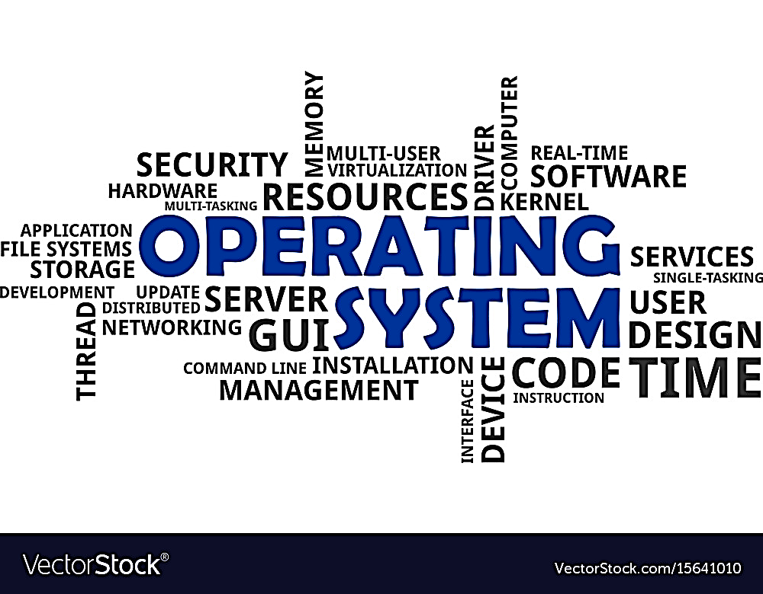

7

Supervised by

Dr.Yasser Fouad

Contents

1

empty

1

empty

1-2

empty

2

empty

of FreeBSD

2

empty

3

empty

3-4

empty

4-5

empty

3

empty

empty

6

empty

7

4

References

